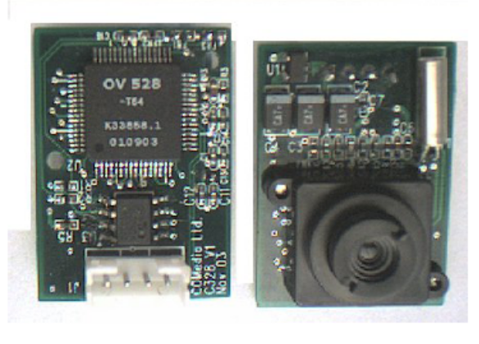
Visible-band camera
Pixels: 640 × 480
Image format: JPEG
Image Size: 40 Kbyte/Image
Interface: RS-232
Power supply: 3.3 V
60 mA
Camera size: 20 × 28 × 10 mm
Cost: $ 89.49
Figure 1 Board Level Camera module
Field of view: 57° Diagonal
Altitude: 300 m
Coverage: 230 × 87 m
Resolution: 0.36 m
Mass: nearly 50 gram
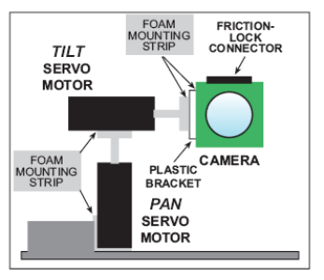
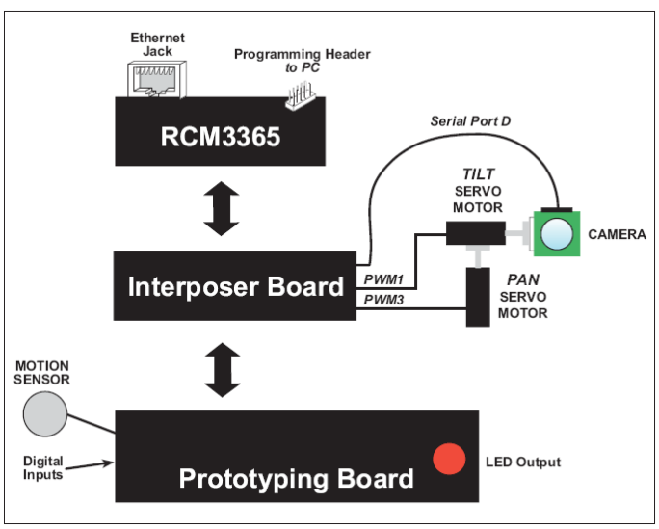
Figure 2 System structure

RCM3365 Core module
Microprocessor: Rabbit 3000 @ 44.2 MHz
Ethernet Port: 10/100Base-T, RJ-45, 3 LEDs
Flash: 512K
SRAM: 512K program + 512K data
Extended Memory: 16 MB xD-Picture Card™ socket support up to 128 MB (NAND Flash)
Board size: 47 × 69 × 22 mm
Power Supply: 3.3 V
250 mA
Cost: $ 89
Mass: nearly 50 gram

Servo Motor
Motor Type: Micro-servo
Torque: 0.4 kg·cm (4.8 V DC); 0.5 kg·cm (6.0 V DC)
Direction: Clockwise / pulse traveling 1500 to 1900 μs
Power: 4.8 V DC – 6.0 V DC / 100 mA
Size: 19.6 x 17.6 x 8 mm
Cost: $ 5 each
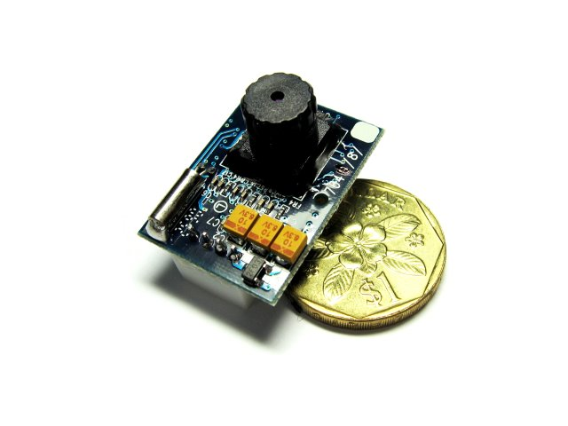
Total cost $ 99.49
Shipping and handling: ?

